**Solution Architecture**

|  |  |
| --- | --- |
| Team ID | PNT2022TMID16902 |
| Project Name | Classification of arrhythmia by using deep learning with 2-d ECG spectral image representation |

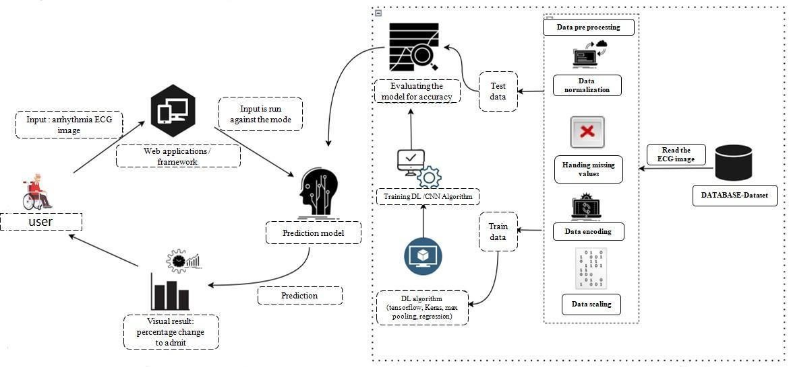

**Technologies needed for Minimum Viable Product deployment**

* Working with HTML & CSS Using Frontend
* Working with image processing technique
* Working with Tensorflow capabilities
* Working with Keras capabilities
* Working Trained CNN model
* Build a web application using the Flask framework**Platform**
* Git & GitHub - Project Management
* IBM Cloud - Hosting
* IBM Watson - Training the Deep Learning Mode

